Minimum Requirements for BYOD devices

Wireless Connection

Tablets or laptops must have this minimum wireless capability: The DEC wireless network installed in high schools only operates on the 802.11n 5GHz standard. Devices with 802.11a/b/g or 802.11n 2.4GHz only will not be able to connect.

Software
Word processing (Eg. Microsoft Word, Pages, Google Drive)
Spreadsheet (Eg. Microsoft Excel, Numbers, Google Drive)
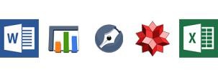
Presentation (Eg. Microsoft PowerPoint, Keynote, Google Drive)
Notetaking (Eg. OneNote, Evernote)
Internet browser (Eg. Internet Explorer, Chrome, Safari)
Antivirus software (All devices must have active antivirus software installed. iPads and
Chromebooks do not need antivirus).

BYOD Checklist

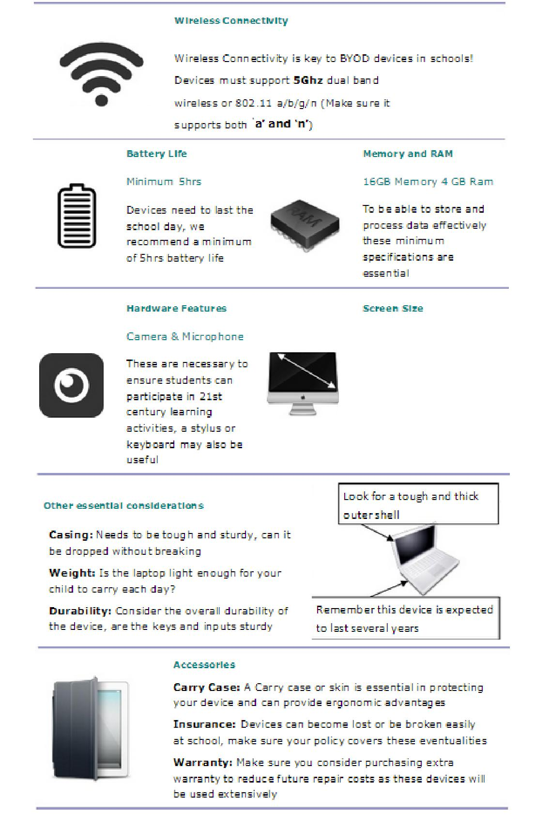

7 inch screen

Whilst all laptops should
be compatible, tablets

need a minimum 7 inch
screen to ensure ease of
use throughout an entire

school day

Existing Devices which meet minimum requirements

Device Type | Windows Laptop |  |  |  |  | Mac Laptop |  | Windows Tablet |  |  | iPad Tablet
Operating | Windows 7 |  |  |  |  | OS X 10.7 or |  | Windows 7, |  |  | iOS 6.0 or higher
System | Windows 8 |  |  |  |  | higher |  | Windows 8,
 |  |  |  |  |  |  |  | Windows RT
Wireless | 5GHz 802.11n |  |  |  |  | 5GHz 802.11n |  | 5GHz 802.11n |  |  | 5GHz 802.11n
Screen Size | greater than 7” |  |  |  |  | greater than 7” |  | greater than 7” |  |  | greater than 7”
Storage Capacity | 64 GB |  |  |  |  | 64 GB |  | minimum 16 GB |  |  | minimum 16 GB
 | hard drive |  |  |  |  | hard drive
RAM | 2 GB |  |  |  |  | 2 GB |  | 2 GB |  |  | 2 GB
Maximum | 2 years |  |  |  |  | 2 years |  | 2 years |  |  | 2 years
Device Age
Minimum | 5 hours |  |  |  |  | 5 hours |  | 5 hours |  |  | 5 hours
Battery Life
Accessories | Protective |  |  |  |  | Protective |  | Protective |  |  | Protective
 | case/cover |  |  |  |  | case/cover |  | case/cover |  |  | case/cover
 | Headphones |  |  |  |  | Headphones |  | Headphones |  |  | Headphones
Other | Up-to-date |  |  |  |  | Up-to-date |  | Up-to-date
Requirements | Antivirus |  |  |  |  | Antivirus |  | Antivirus
Device Example | Lenovo ThinkPad |  |  |  |  | 11-inch MacBook |  | Microsoft Surface |  |  | iPad
 | X131e |  |  |  |  | Air |  | RT |  |  | WiFi 16GB
 | http://shopap.leno |  |  |  |  | http://www.apple. |  | http://www.micro |  |  | http://www.apple.
 | vo.com/au/en/lapt |  |  |  |  | com/macbook-air/ |  | soft.com/surface |  |  | com/ip
 | ops/thinkpad/x- |  |  |  |  |  |  |  |  |  | ad/overview/
 | series/x131e/

Important Note:

Devices based on the Android operating system are not recommended.

This document should be read in conjunction with BYOD Update 3/2/2017.

Bankstown Public School 2 8.02.17

